**Name:** V Venkata Sri Prasad

**Batch:** Data Engineering

**Date:** 29/01/2024 – (Day 8)

**Functions concepts:**

**String Function:**

**capitalize**

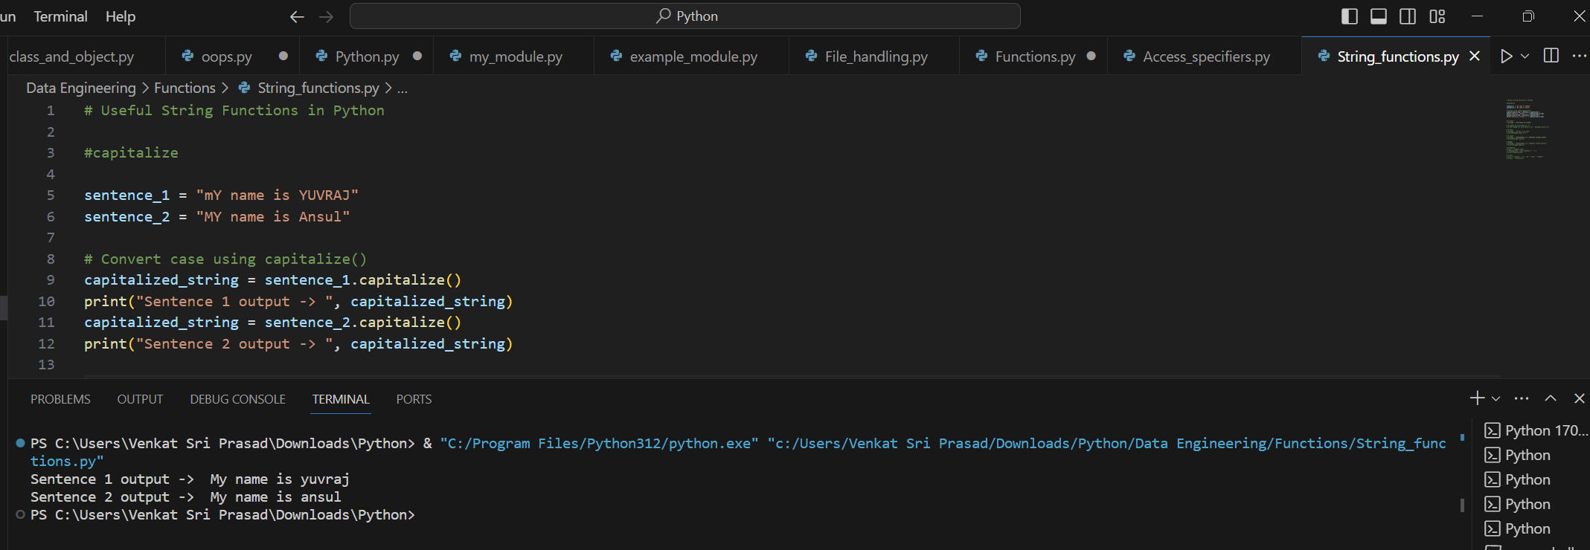

**Count**

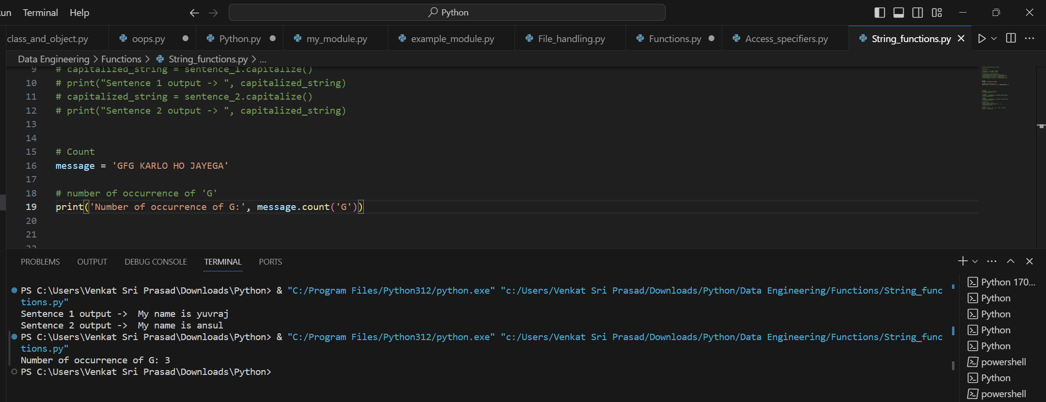

**Find**

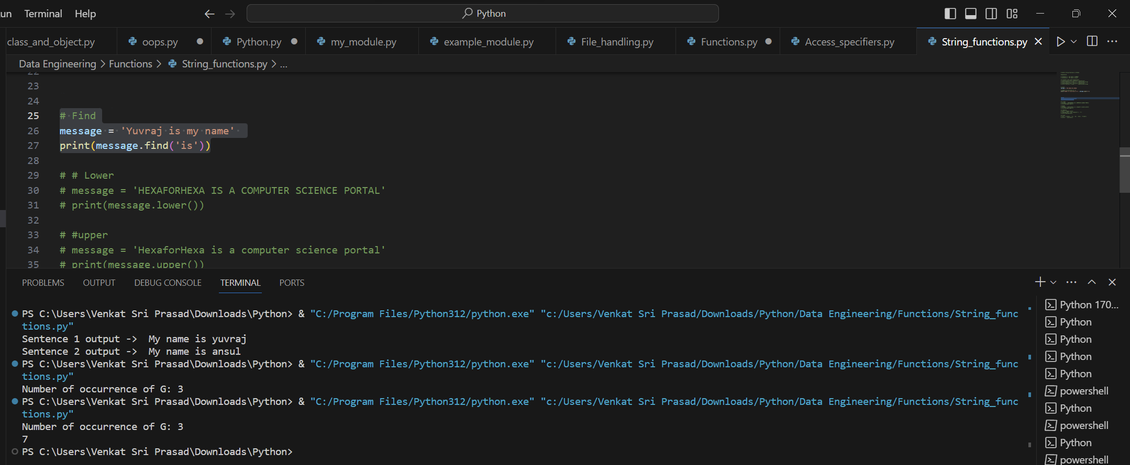

**Upper and Lower:**

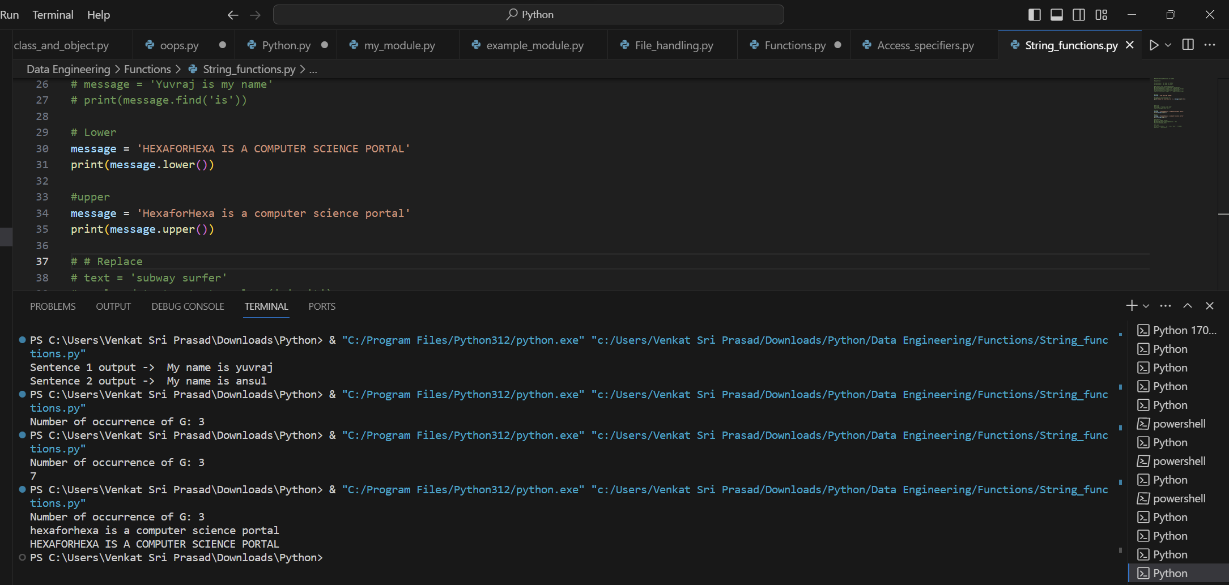

**Replace:**

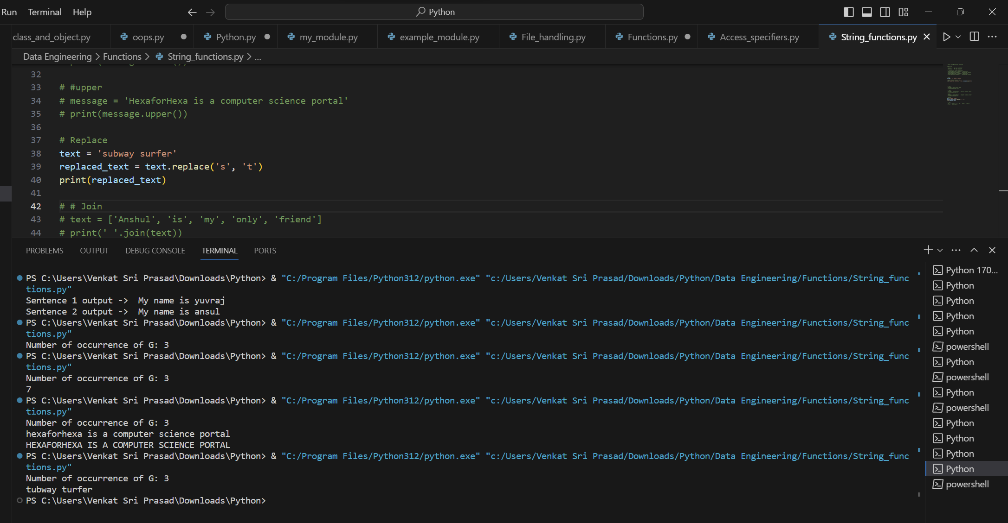

**Join**

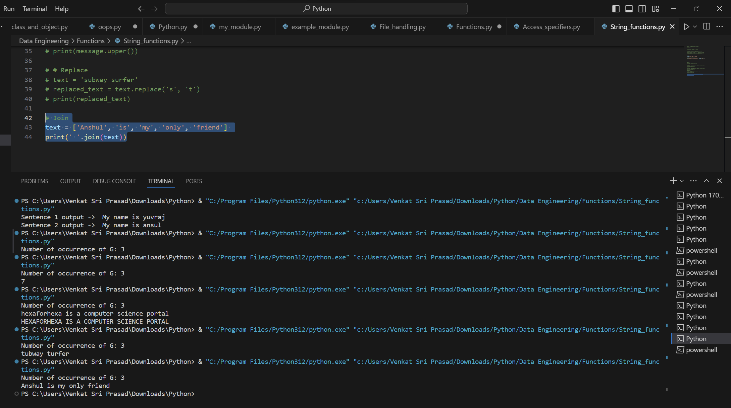

**Date and Time Function:**

**Max time and min time**

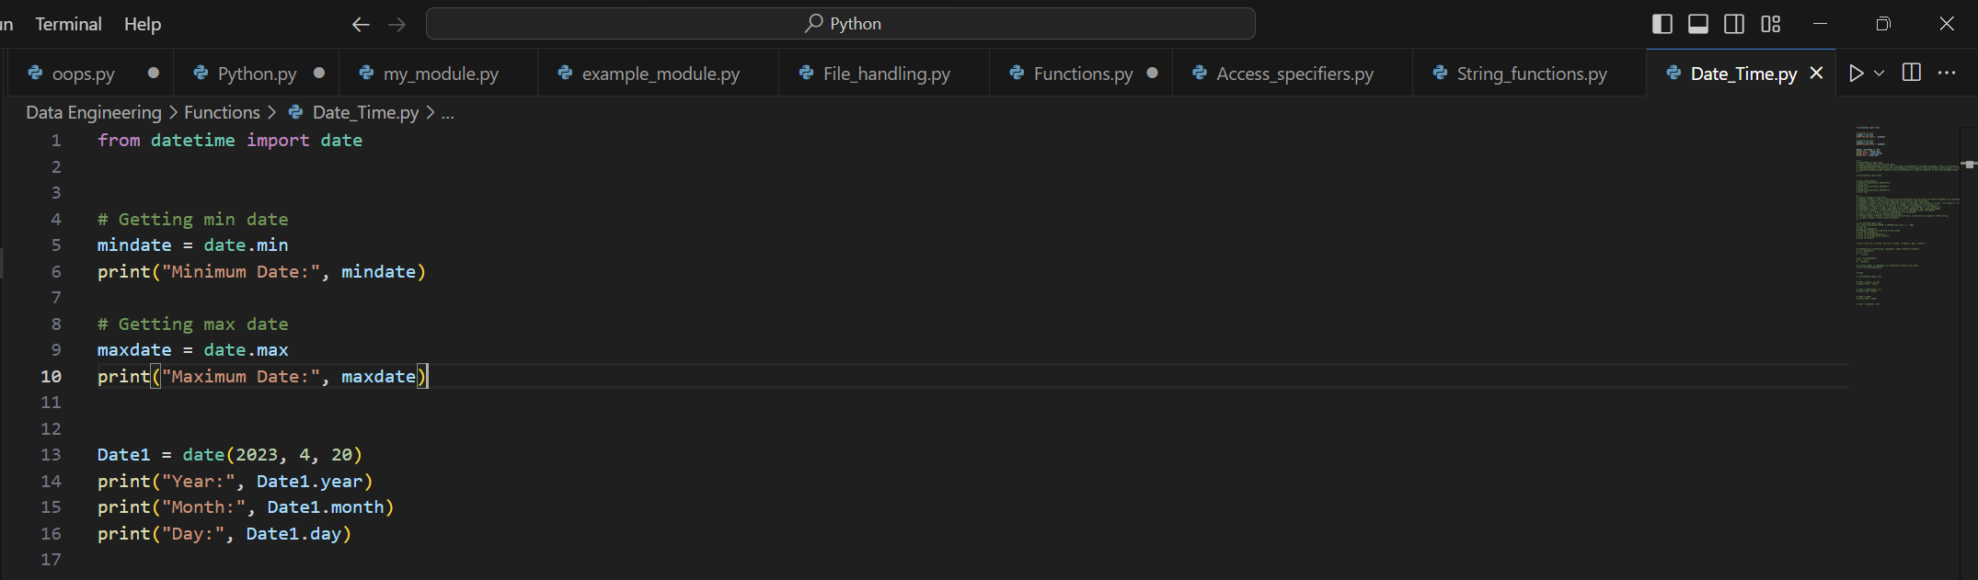



**Isofformat**

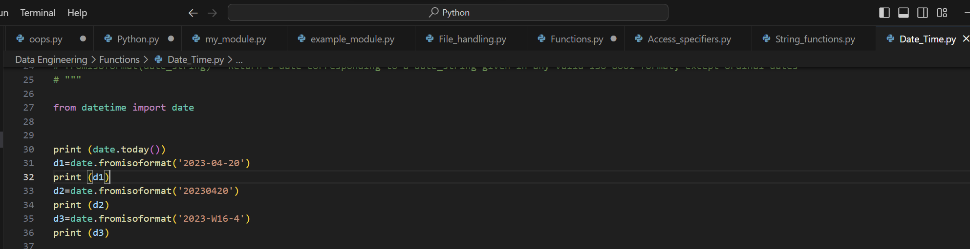



**Instancemethods**

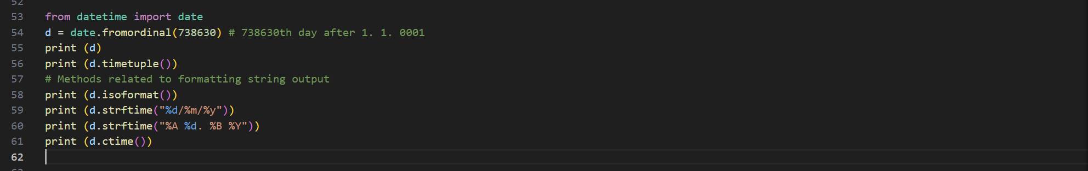

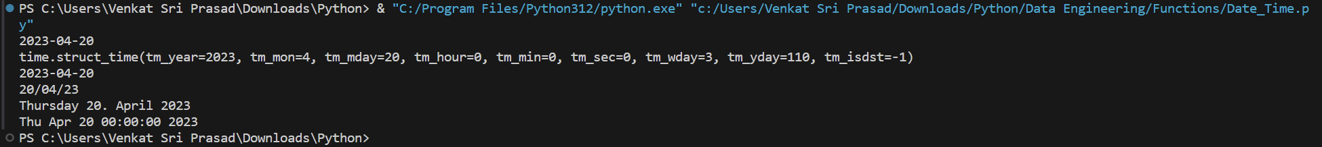

**Python Functions:**

**Function to calculate area of a rectangle**

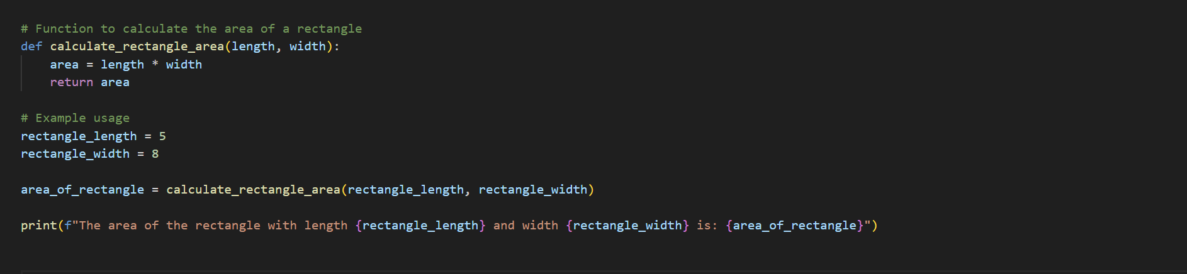



**Default Argument Values**

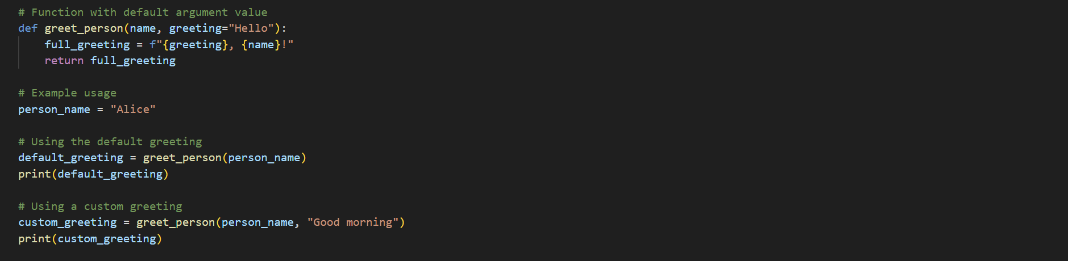

**  
Keyword Arguments**

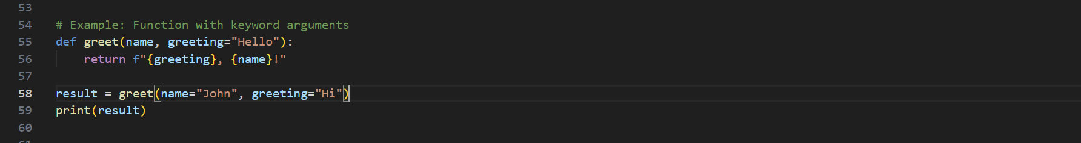

**  
Special parameters**

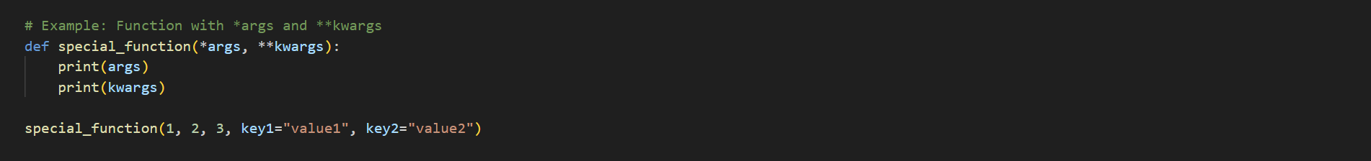

**  
Arbitrary Argument Lists**

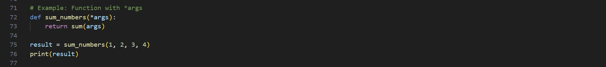



**Lambda Expressions**

